
CSPE65: MACHINE LEARNING TECHNIQUES AND PRACTICES

Assignment - 1
106119100 - Rajneesh Pandey


Code is runned on Kaggle Notebook

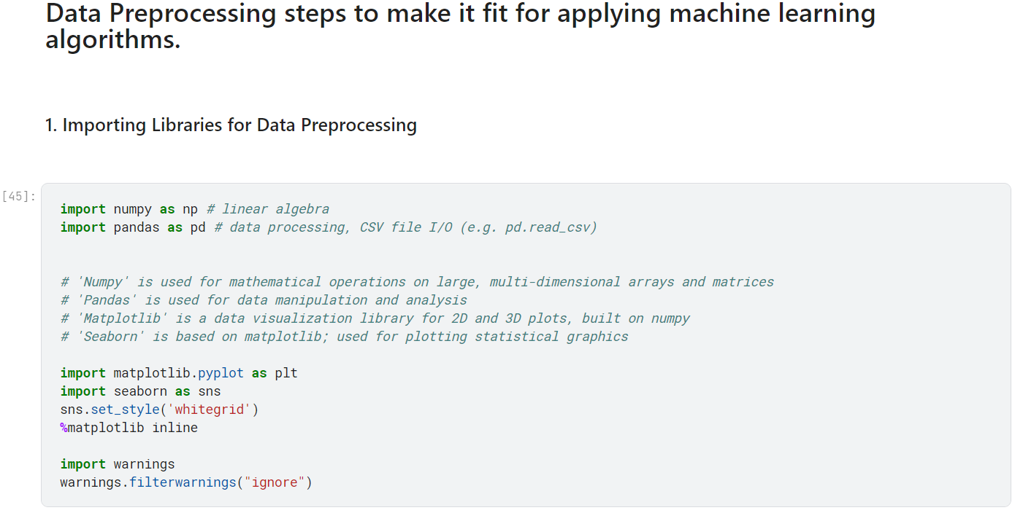

Reading the data and viewing them

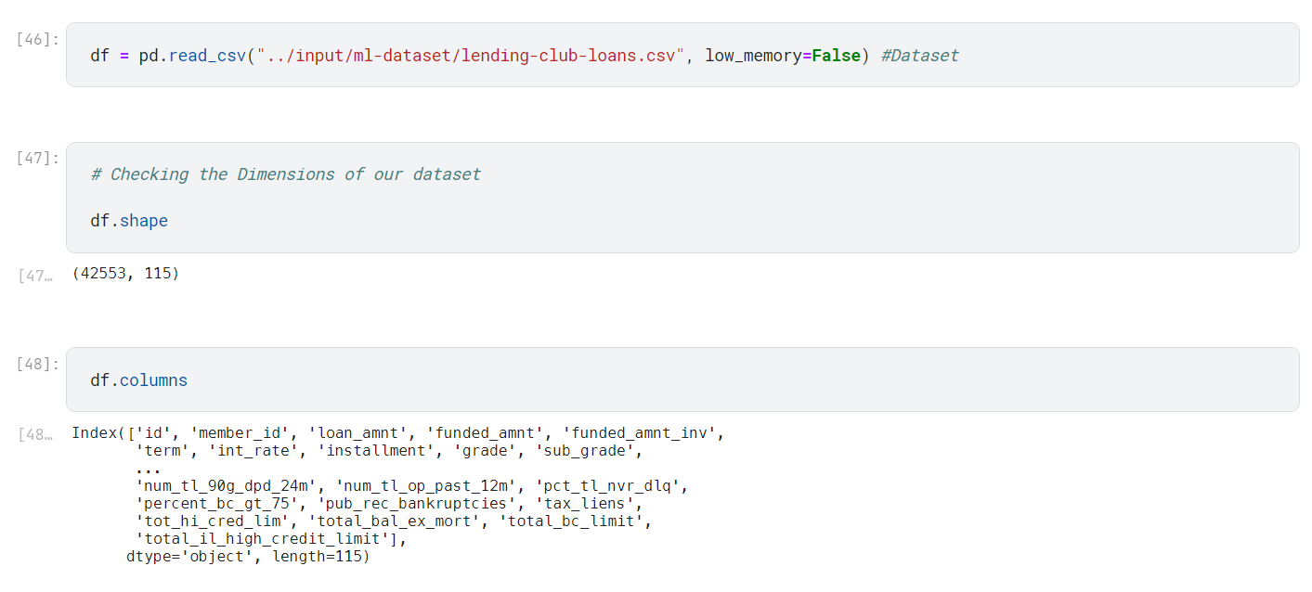

To get familiarize ourselves with this dataset, and understand what these columns represent.
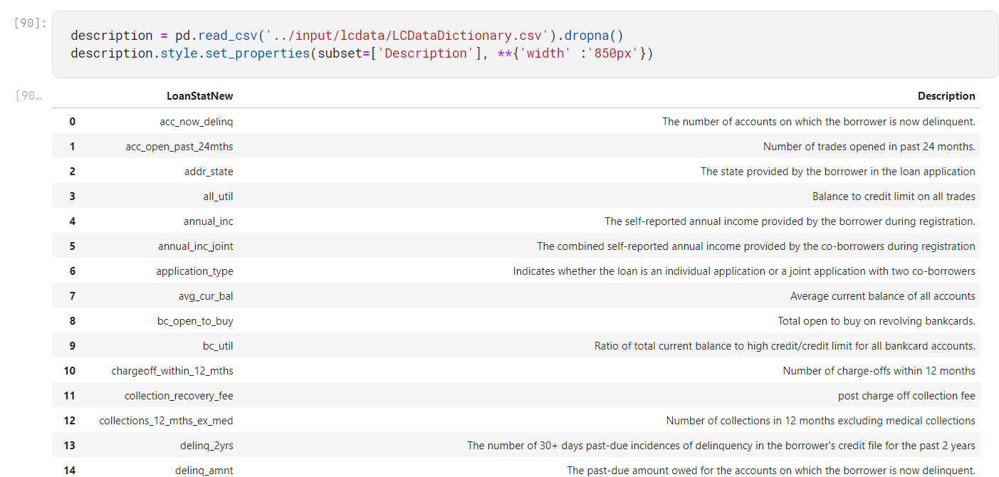

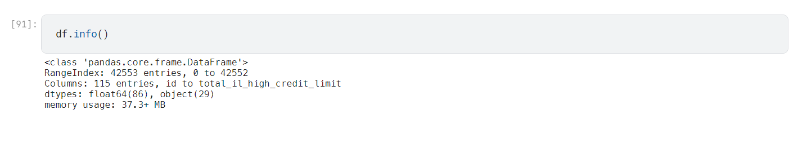

It is evident from the above heatmap that our dataset contains a lot of missing values and we can not use feature that has so many missing values.

More Darker Color represent the data is filled.

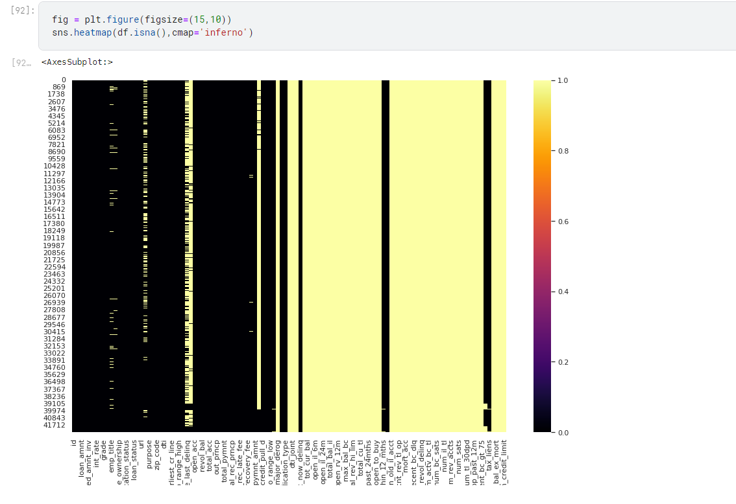
Another thing I want to examine is that how many loans have a default loan status in comparison to other loans.

So,
A common thing to predict in datasets like these are if a new loan will get default or not.
I will be keeping loans with default status as my target variable.

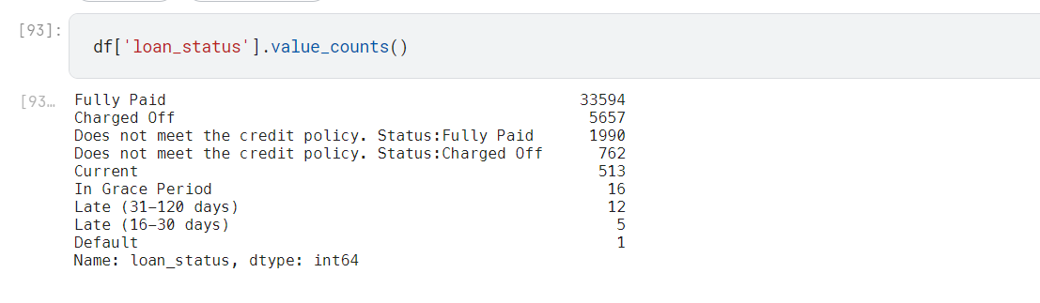

Target feature
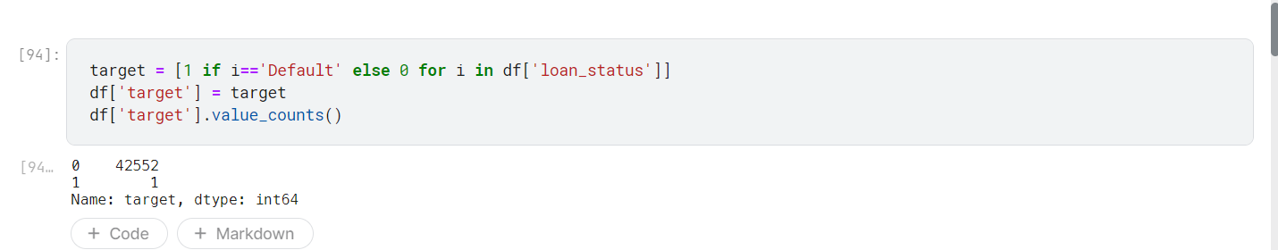

Finding the null percent to see the null values in the data frame

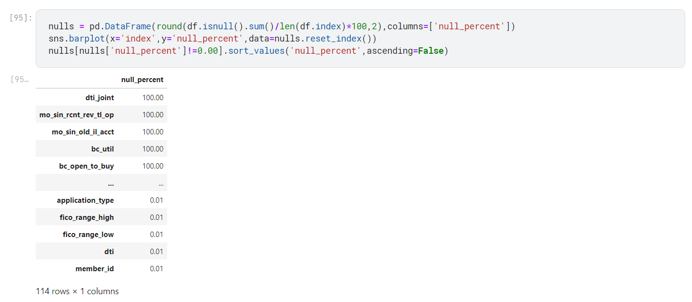

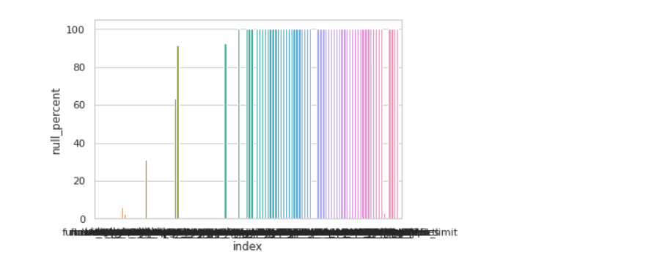

There are several columns that fit into one of the following categories:

Unnecessary data: URL to view the loan.
Redundant data: Loan description may be useful to some, but loan purpose fits our needs
User provided information: Employer titles may offer some insight into employment industry.
Operational data: The next payment date for the loan at the time the data was generated is not relevant to us

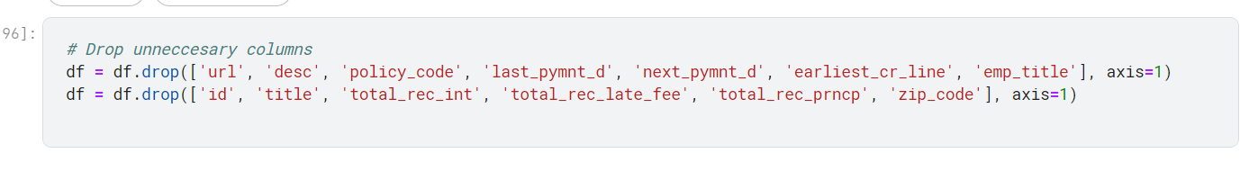
Since customer has taken loan again, we cannot drop member id.
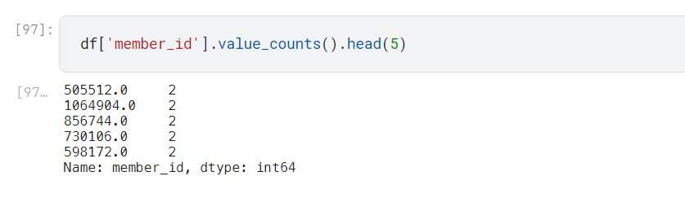

Some rows that we decided were not relevant to our needs.
The 'loan_status' column is the source of answer to the main question that if people are paying the loans they take out.

Some records with a loan_status of “Does not meet the credit policy". These may be older loans that would simply not be accepted under LendingClubs current criteria.
As these data points will provide no value moving forward, I have excluded them from our data.

Similiarily, recently issued loans could mislead our analysis, as no payment has been expected yet.

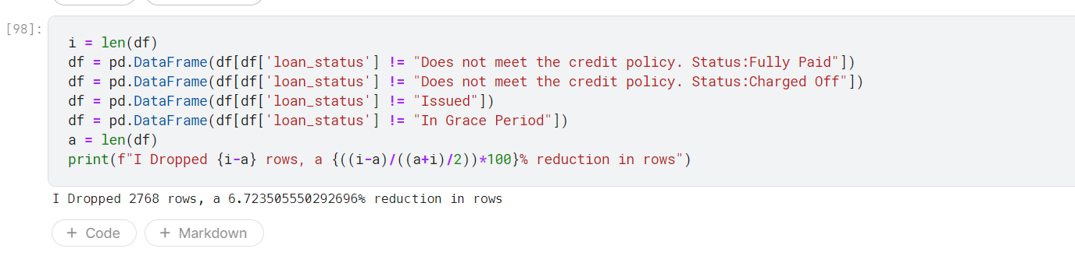

Converting the data to proper data type
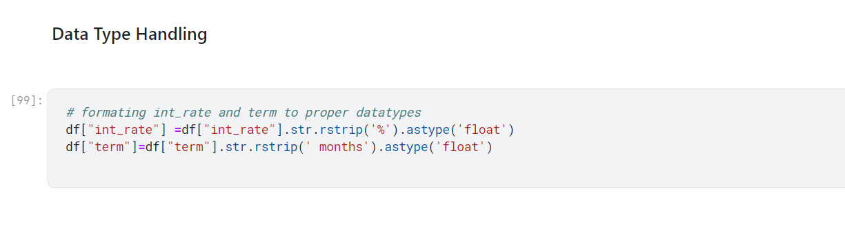
Now again viewing the data
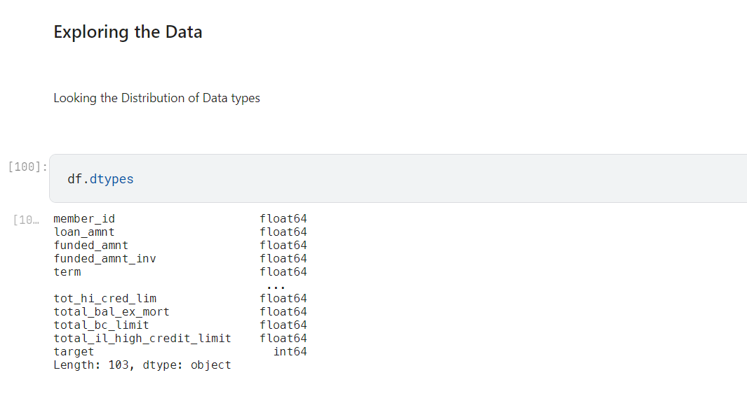
Let us see how many Object type features are actually Categorical
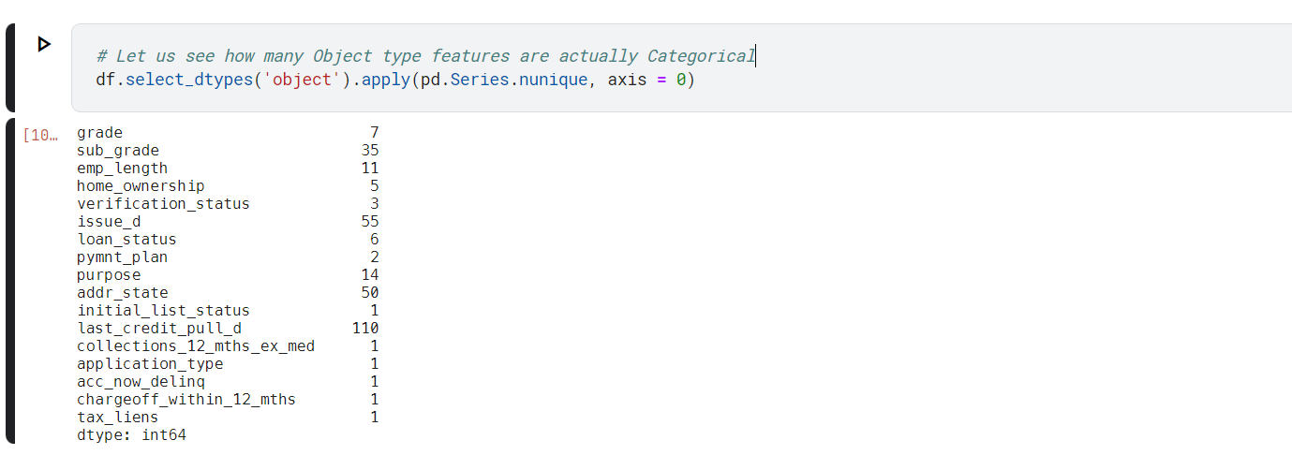
It can be seen that people who have worked for 10 or more years are more likely to take loans
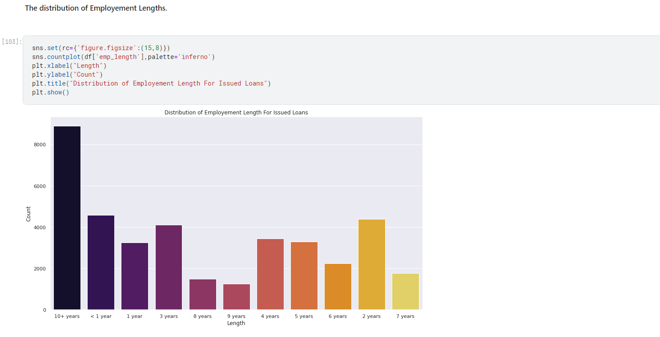

Plotting the box plots to see the outliers

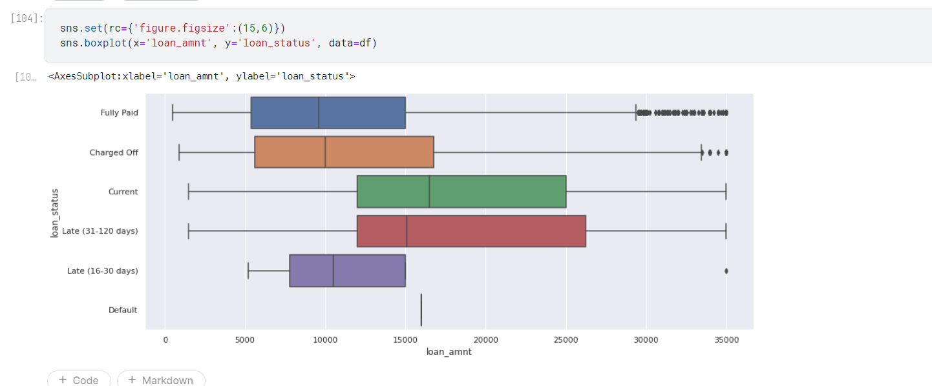

Cleaning of Data

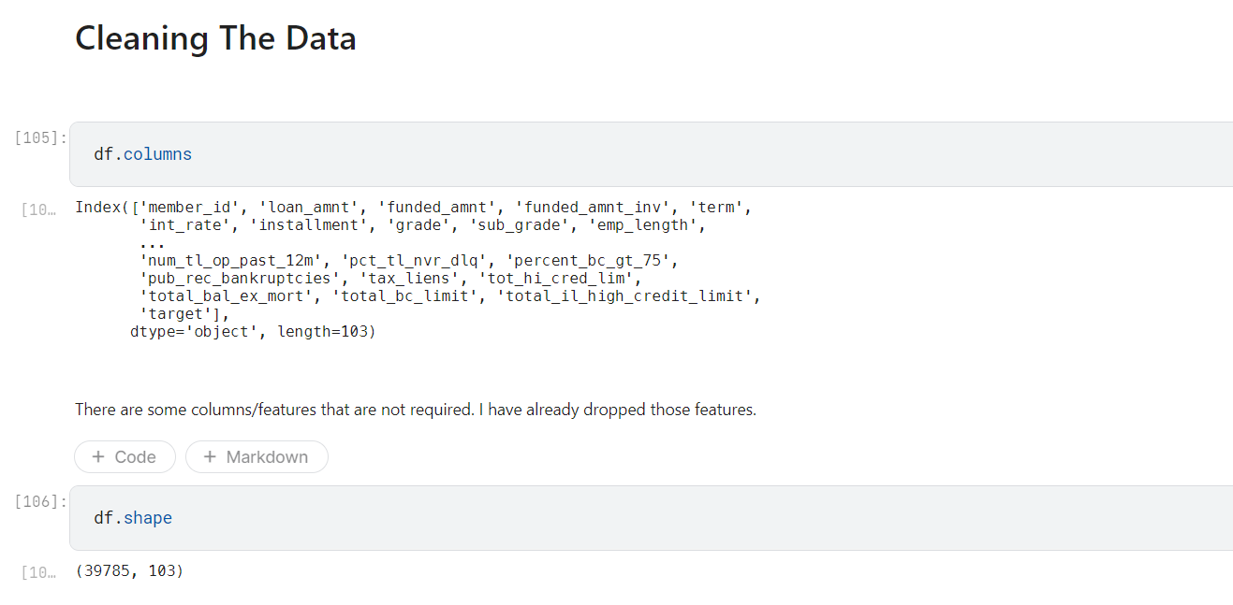

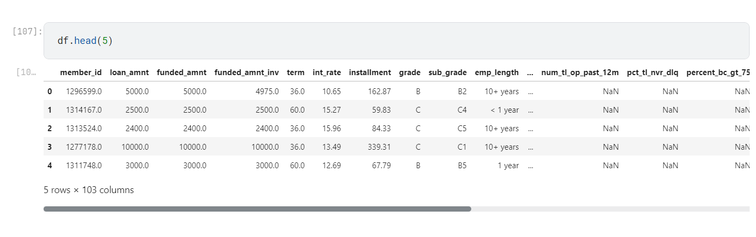

Dropping the colunms with more than 75% null values

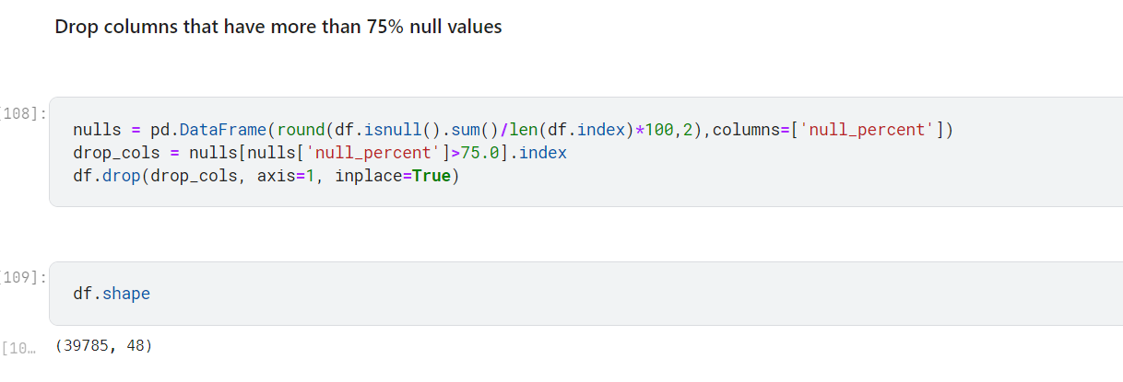
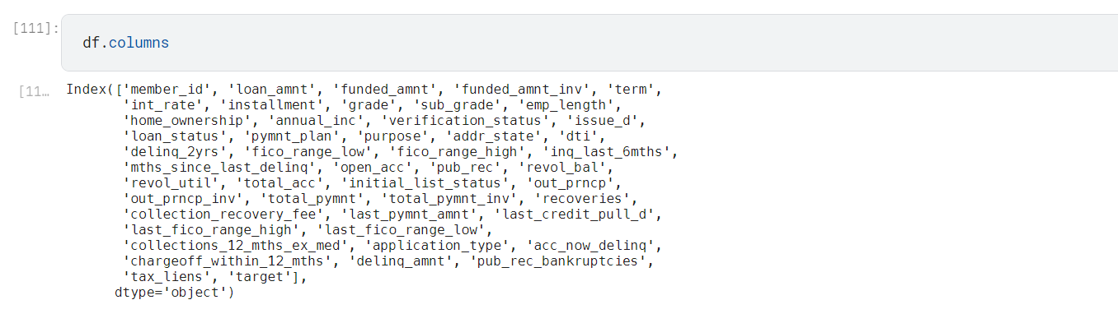

Replacing the null values in the below column with median
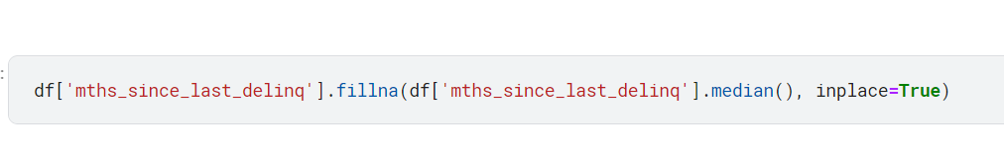

Making the categorical Data item list

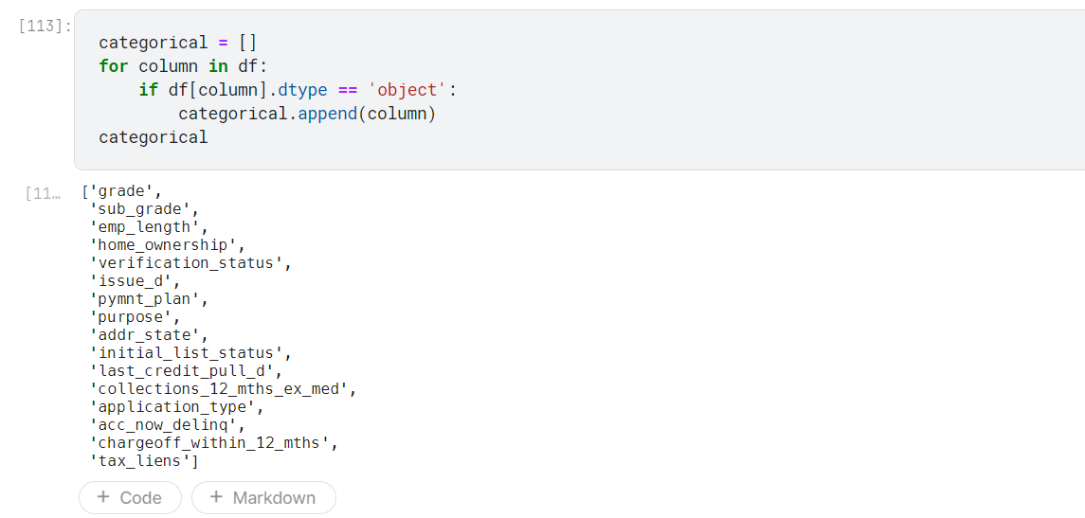

Defining the fuction for various task to perform on data

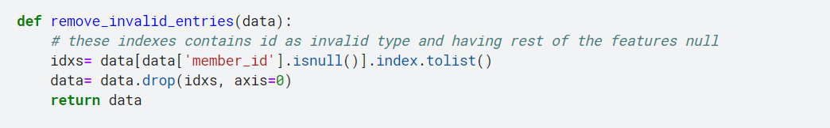
This function is to remove invalid entries in the data

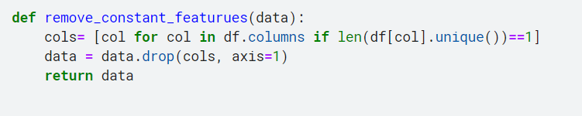
This function is to remove constant feature in the data

Remove duplicate column and duplicate row
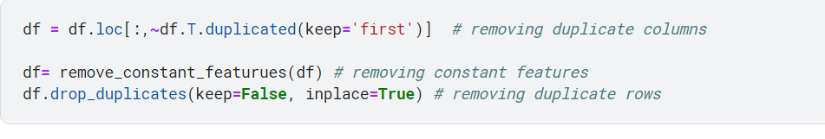

Creating the mapping dictionary to convert the categorical data
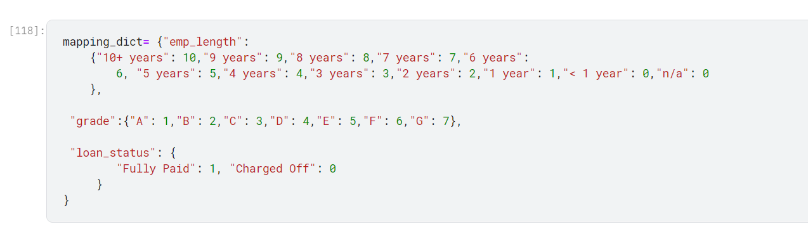

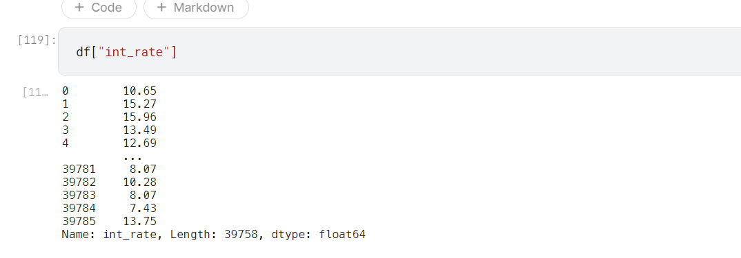
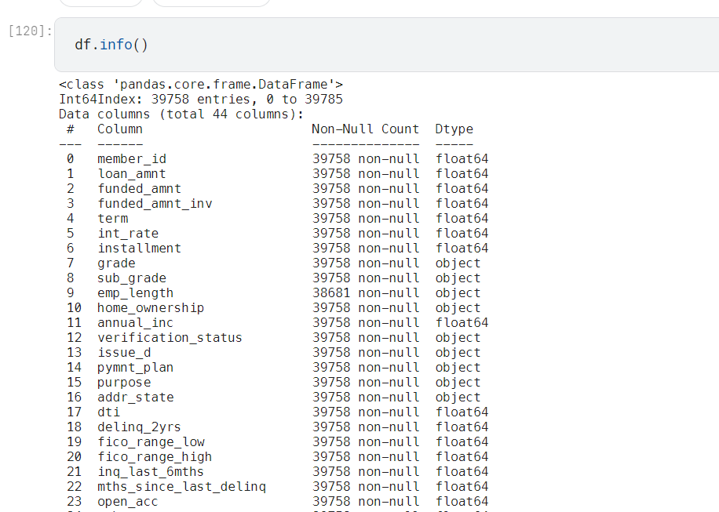

Function to handle the outlier that we have seen in the above
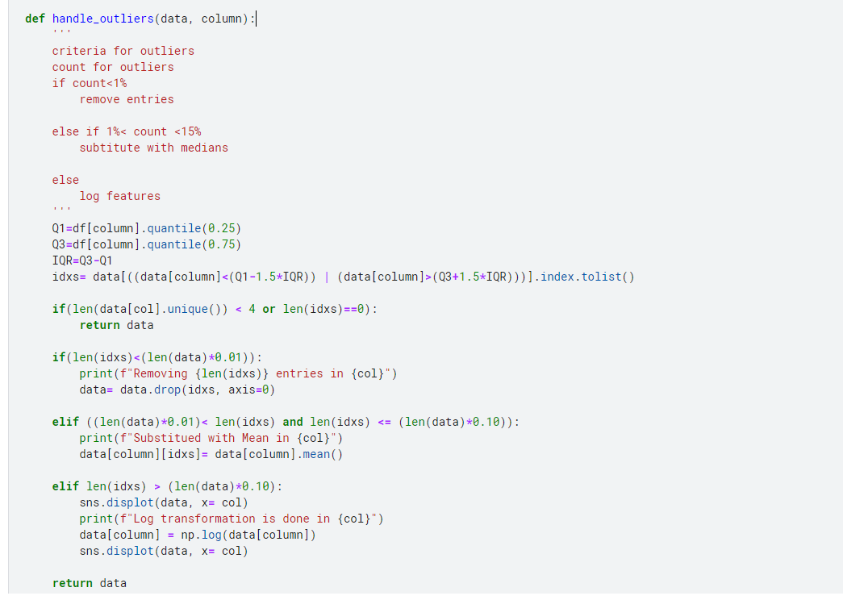

Creating num_feature and cat_feature for conversion and converting the categorical data

Also handling the outliers

